Drive in Carcoon

The latest evolution of the Carcoon.
Drive-in Carcoon provides all the protection of the normal inflatable Carcoon while ensuring that nothing ever touches your vehicle.
Simply drive the vehicle into the Carcoon, zip shut the access panel and turn the power on, protecting your vehicle has never been so easy.

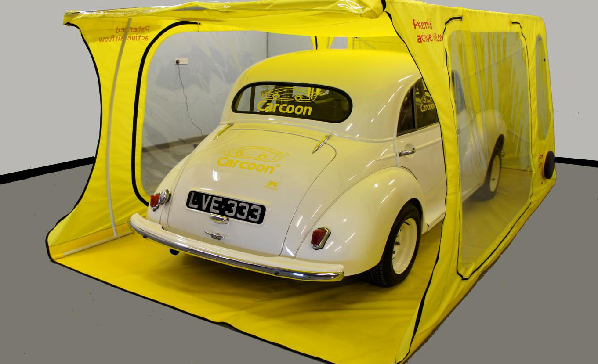

Drive-in Carcoon in access mode

Ex Small $1350.00 Dimensions are overall inflated size of the capsule | 400L x 200 W  Height: 175cm
Small $1395.00 | 433L x 230 W  Height: 175cm
Medium $1495.00 | 488 Lx 230 W  Height: 175cm
Large $1595.00 | 538L x 230 W  Height: 175cm
Ex large $1695.00 | 638L x 230 W  Height: 175cm
Extra high + $150.00  Add $150.00 to cost of unit | Height: 190cm
Delivery cost throughout Australia $69.00
Free Delivery for January 2012

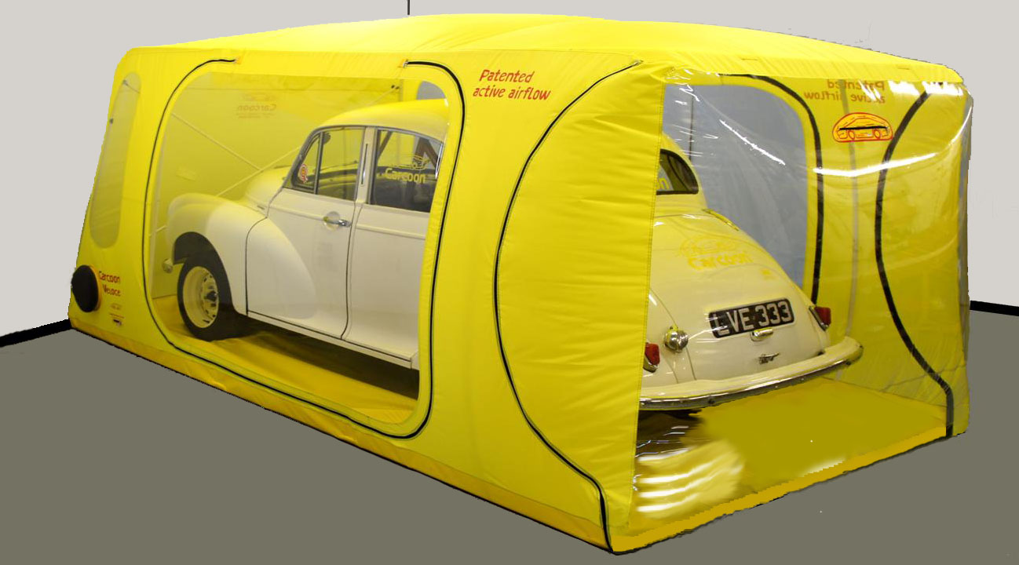
Drive-in Carcoon in storage mode

Drive-in Carcoon features;

- Zippable main Entry door.
- Zippable side panels (allowing maintenance, placement of axle stands etc)
- Internal powder coated support frame (supports the Carcoon when access doors are opened or power is turned off).
- Twin low energy circulation fans.
- Six filter filtration system.
- Battery management system.
- Three year Warrantee including electrical components.
- 30 day absolute money back guarantee.
- Colour choices, Red, Blue, Black, Yellow, Silver. (subject to availability)

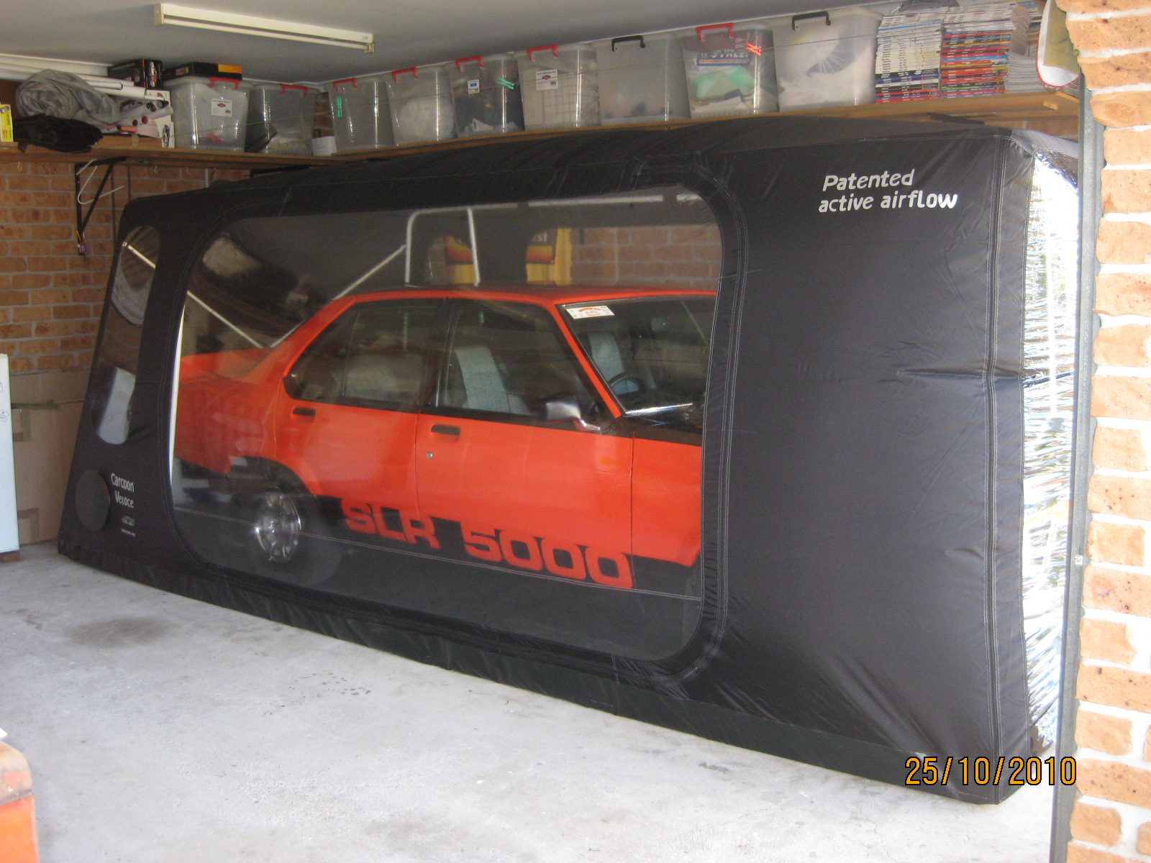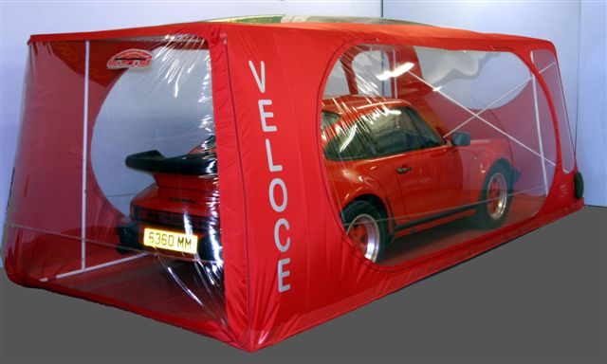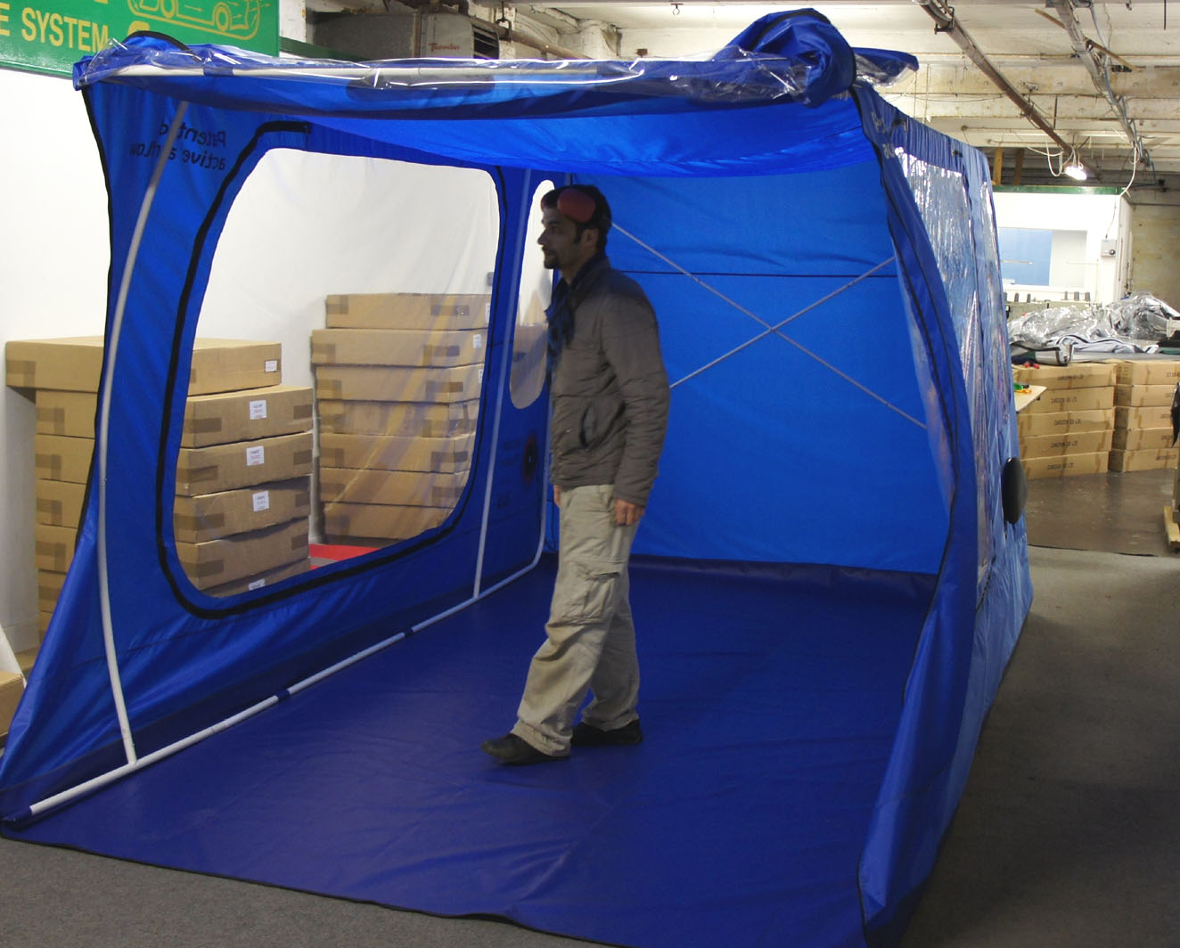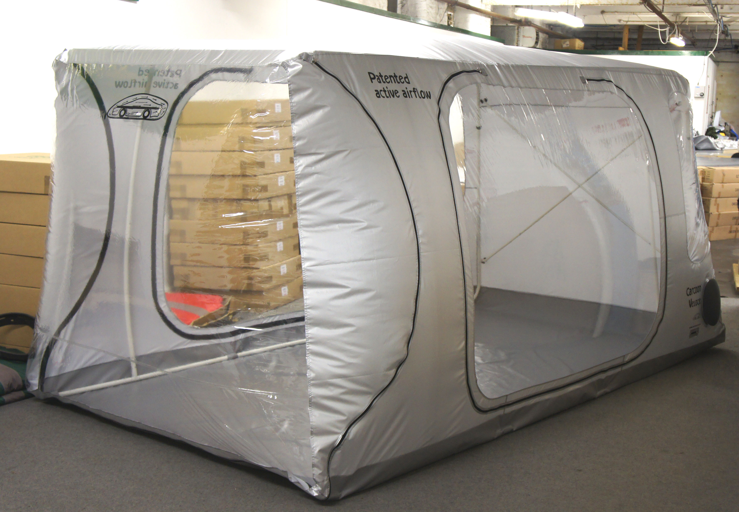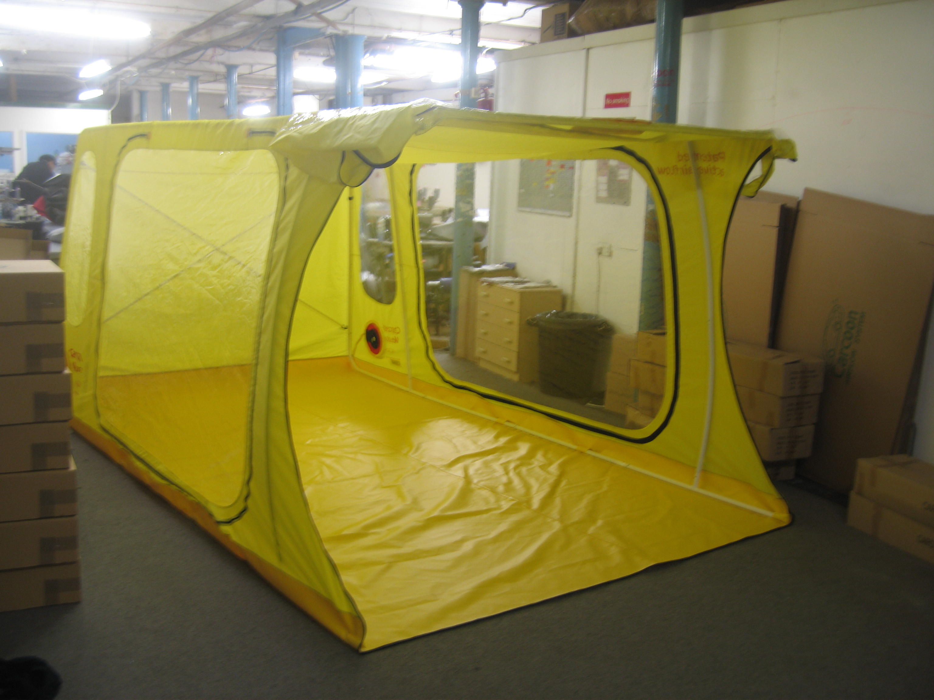
Black Red Blue Silver Yellow

© Carcoon Australasia
Ph 617 5537 7766:
25/38 Kendor Street, Arundel Qld 4214.
Email: info@carcoon.com.au,
www.carcoon.com.au

